**THE TURN OF THE CENTURY**

FOCUS: HISTORICAL CONTEXT DEFINING THE BASIC LITARARY MOVEMENTS FROM THE BEGINNING OF THE 20TH CENTURY

WORLD WAR I

When World War I broke out between the Allies (Britain, France and Italy) and the Central powers of Germany and Austria, Woodrow Wilson attempted to maintain American neutrality, although the provision of substantial loans and supplies to the Allied forces could leave little doubt as to whose side the United States was on. Following the sinking of the passenger ship ‘Lusitania’ (with 128 American passengers on board) and subsequent attacks on American merchant shipping by the German navy, Wilson asked Congress to declare war on Germany in 1917.

Although American forces only arrived en masse towards the end of the war, two million Americans had volunteered to fight and more than three million were drafted: the arrival of American troops in France made an important contribution to the Allied defeat of Germany. At home a spirit of patriotism prevailed and many citizens made a conscious effort to help finance the war by purchasing billions of dollars, worth of Liberty Bonds. Famous movie stars promoted the bonds around the country and patriotic songs were composed in honor of the ‘doughboys’ fighting in far away Europe.

In 1919 a peace conference was called in Paris to decide the fate of a Defeated Germany. President Wilson had prepared an ‘honorable peace’ for Germany: his famous ‘Fourteen Points’ were, however, ignored for the most part, the Allies preferring a series of more punitive measures, including substantial war payments (so-called reparations) and the seizure of German colonies and territories. The only proposal to be accepted was that of the setting up of a ‘League of Nations’ whereby cooperation between participant members was to ensure future peace and security in the world.

Ironically, the League of Nations – forerunner of the more successful present-day United Nations – was accepted in Europe, but when Wilson returned to America it was rejected by the Senate. This decision virtually condemned the United States to a period of isolationism in the field of international affairs for the next twenty years – until the outbreak of the Second World War once again led to cries for assistance.

POST-WAR AMERICAN SOCIETY

Post-war America witnessed continued growth in terms of population, and a continued movement away from rural areas to the ever increasing number of sprawling urban cities. By 1929 the population had risen from its level of 102 million to 122 million. For the first time the majority of the population was living in towns and cities. This trend also brought about changes in the everyday lives of American people: city life was inevitably more hectic and impersonal, and family ties inevitably became weaker.

As the prices of manufacturing articles fell, people could afford an astonishing range of new consumer durables – electric washing machines, telephones, radios and, most importantly, cars. Indeed, improvements in technology meant that between 1920 and 1930 the number of cars sold almost tripled from 8 million to 20 million. Leisure time was taken up with movies, plays and sporting events: silent films were shown in the so-called dream palaces.

THE ROARING TWENTIES

The ‘Roaring Twenties’, as they fondly became known, brought with them radical changes in lifestyle. The nineteenth amendment to the Constitution (1920) had given women the right to vote, and, armed with their newly acquired independence, they quickly took advantage of the new opportunities opening up around them in the field of work. Some women (known as ‘Flappers’) rejected the more sober clothes of their predecessors in favor of shorter skirts and daring hairstyles.

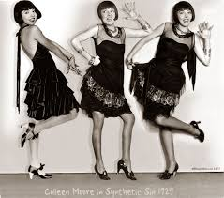

Flappers- *young women in the 1920s who wore short skirts, listened to jazz music and showed their disdain for what was considered accepted behavior. They defined the modern look for the women (excessive make-up, drinking alcohol, smoking, driving cars…). Viewed by many at the time as outrageous, immoral or downright dangerous, they are now considered the first generation of independent American women.*

The eighteenth ‘Prohibition’ amendment (1920) had attempted to outlaw sales of liquor, but ‘**speak-easies**’ (or secret nightclubs) ensured that ‘**bootleg’** (illegally procured) alcohol was available in generous quantities to an ever thirsty public.

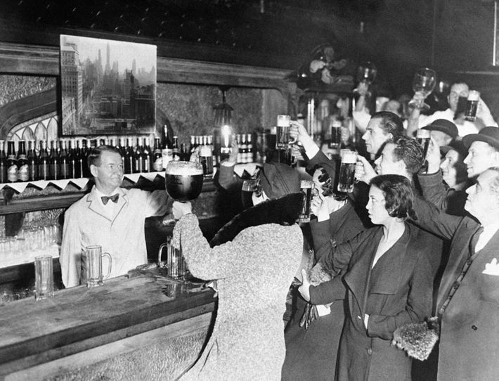

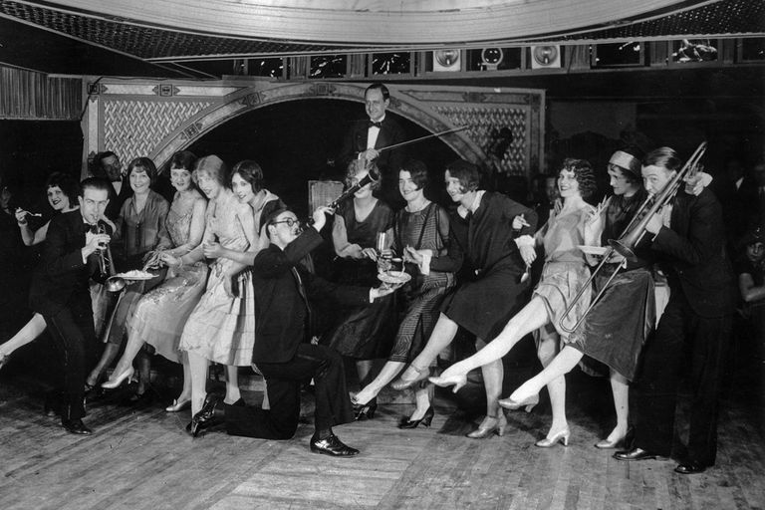

People rushed to the speak-easies (🖜 on the pictures) to listen to the new jazz sounds and dance the latest steps to the rhythms of the Charleston. The bootlegging of liquor had its darker side however: gangs of thugs seeking control of the illegal alcohol market proliferated in the larger cities and the levels of crime and violence rose considerably.

A series of Republican administrations under Harding (1921-1923), Coolidge (1923-1929) and Hoover (1929 - 1933) attempted to curb the newly unleashed forces of hedonism in an attempt to restore older and more traditional social values. Indeed, Harding’s message to the electorate in 1920 was *A Return to Normalcy*. The efforts of federal government to curb contemporary excesses found sympathetic support in other sections of society. Religious revivalism became increasingly popular in both rural and urban areas, and after a period of relative anonymity the Ku Klux Klan returned to its former strengths. It took blacks, Jews, Catholics and political radicals as its scapegoats for society’s ills, and at its height was able to count a membership of over two million.

THE WALL STREET CRASH

Not everyone benefited from the economic prosperity of the 1920s: while manufacturers and large companies continued to expand, and were undoubtedly helped by sympathetic, conservative governments intent on promoting the interests of big business, farmers and laborers actually witnessed a decline in the value of their wages. Tariff duties on imported goods were increased in order to stimulate home industries and credit terms were eased considerably. Little was done to help either American farmers or laborers, however, and their resulting poverty inevitably led to a reduction in domestic demand. Very soon America was producing more than it could actually consume. Confident of high returns on their investments in the stock market, increasing numbers of Americans bought stocks during the 1920s, but towards the end of the decade wild bouts of speculation pushed the value of these investments to artificially high levels. In October 1929 prices started to decline and the resulting panic led to the great stock market crash in which it has been estimated American investors lost over $50 billion. The Great Depression which followed lasted for a full ten years.

THE GREAT DEPRESSION

The failure of the banking system during the crash of ’29 meant that hundreds of thousands of people lost their life savings overnight.

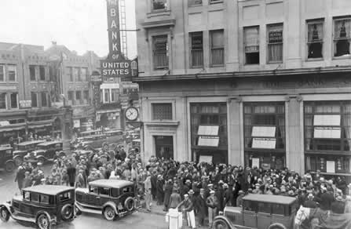

***A picture showing people outside a closed bank during the Depression***

Businesses were forced to cut back on production and thousands of factories were closed: millions of workers lost their jobs and at the height of the depression in 1933 over 13 million people were unemployed. In rural areas it is estimated that over 750,000 farmers lost their land.

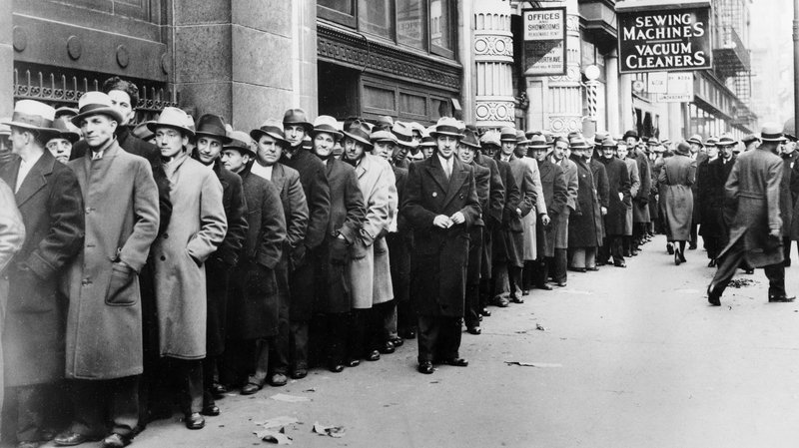

***Thousands of unemployed people waiting outside the State Labor Bureau in New York City in 1933.***

THE NEW DEAL

In 1932 the Democrat F. D. Roosevelt replaced Hoover as President of the United States. During the election campaign he had promised firm measures to deal with the depression and he was true to his word. His program for recovery was called the New Deal, and it involved greater government intervention in the affairs of the economy than had ever been seen before. ‘The only thing we have to fear,’ said Roosevelt, ‘is fear itself’, and he quickly set about the total reorganization of the economy.

Loans were made to industry in order to stimulate growth and fight unemployment; banks were made subject to a series of stricter regulations and stock market activities were more carefully controlled; a program of public works projects created new jobs and farmers were provided with relief schemes; the newly created Social Security Board helped elaborate a system of social security. By the end of the decade these measures were beginning to have positive effects, and such was Roosevelt’s popularity that he was re-elected four times – a record in the history of the United States. A much needed boost to the economy in the form of military spending was provided by the Second World War – the next serious challenge to America’s development as a world power.